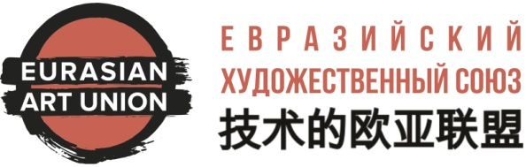 | To the President of  the Russian branch of  the Eurasian Art Union,  Honored Artist of Russia  Mr Leonid A.Fedorovich

APPLICATION FOR ENTRY
Please accept me as a member of the RPO "Eurasian Art Union"* (further as the "Union") as an individual member in the guild and section listed below. I am acquainted with the charter of the Union. I share the goals and objectives of the Union and I am ready to participate in their implementation.
I undertake to comply with the Charter, actively participate in the activities of the Union and make timely membership fees.
Information about me:
Surname:
Name:
Patronymic:
Date of Birth:
Place of Birth:
Citizenship:
CONTACTS
Mobile phone:
Additional telephone:
E-mail:
Address (postal):
Index:
EDUCATION
Education:  (type in by list) | № | Name: | Year of ending:  (or what course) | Specialty:
Education:  (type in by list) | 1
Education:  (type in by list) | 2
Education:  (type in by list) | 3
Education:  (type in by list) | 4
Education:  (type in by list) | 5
PROFESSIONAL EXPERIENCE
Participation in public unions and associations | № | Name: | Year of entry:
Participation in public unions and associations | 1
Participation in public unions and associations | 2
Participation in public unions and associations | 3
Participation in public unions and associations | 4
Participation in public unions and associations | 5
Participation in public unions and associations | 6
Ranks
(list)
Received awards
(list)
YOUR WISHES FOR PARTICIPATION IN THE GUILD / SECTION (specify the desired guild / section)
Guild
Section
By sending the completed questionnaire, I give permission to the RPO "Eurasian Art Union" to use the above information about me in order to ensure the activities of the Union, namely, process, collect, record, organize, accumulate, store, specify (update, change), extract, use , transfer (including assigning processing to other persons), depersonalize, block, delete, destroy - my personal data: last name, first name, patronymic name, home, mobile, work phone number, date, year and place of birth address, address, e-mail address, social media pages and other information listed in the table above. I also give permission to the Union to inform me about new developments in the field of art, special offers, publications, master classes, lecture halls, round tables and other socially significant information by processing the above personal data and sending letters and messages to the email address I specified and / or mobile number. The consent may be withdrawn by me at any time by sending a written notice to the address: 119049, Moscow, Krymsky Val, 8 / 2, room. "Union of Artists" or E-mail: info@artunion.pro. Attached to this statement:
Account card | Photos of my works | Personal photo | List of publications | Extended Autobiography
Yes __ No __ | Yes __ No __ | Yes __ No __ | Yes __ No __ | Yes __ No __

Place of filling: | -
Date of filling: | -
Signature: | -
Attention: this form must be filled in, printed, signed, scanned or photographed and sent to e-mail: info@artunion.pro
*RPO - REGIONAL PUBLIC ORGANIZATION "CREATIVE COMMONWEALTH" “EURASIAN ART UNION"

